# **References:**

ardupilot.org/dev/docs/raspberry-pi-via-mavlink.html

https://www.youtube.com/watch?v=DGAB34fJQFc

# **Connecting Raspberry Pi:**

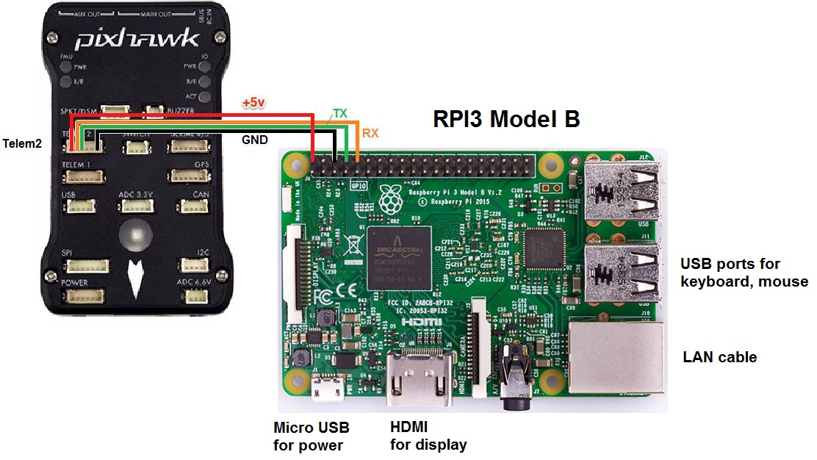

# **Remove the +5 connection when powering through the USB port(Recommended)**

# **Installing Required Packages:**

# **> sudo apt-get update #Update the list of packages in the software center**

# **> sudo apt-get install screen python-matplotlib python-opencv python-pip python-numpy python-dev libxml2-dev libxslt-dev python-lxml**

# **(If this part gives an error of lists lock then do > sudo reboot now and run the command again)**

# **> sudo pip install future**

# **> sudo pip install pymavlink**

# **> sudo pip install mavproxy**

# **Running Mavproxy:**

> sudo raspi-config

Go to interfacing options and disable serial by clicking NO two times

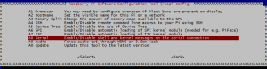

> sudo reboot now

> nano /boot/config.txt

Add in the end

enable_uart=1

> sudo reboot now

> sudo -s

> mavproxy.py --master=/dev/ttyS0 --baudrate 57600 --aircraft MyCopter

# Installing Dronekit:

> sudo -H pip install dronekit==2.9.1

> sudo -H pip install dronekit-sitl==3.2.0

To verify the installation run :

> python

> from dronekit import connect